**TK-550**

# —Cheyenne's leading office supply store for over 50 years—

# is proud to announce the acquisition of

# A. Datum Corporation,

# featuring the following:

* Imaging Systems
* Photocopiers
* Laser Printers
* Electric and Electronic Typewriters
* Desktop Computers
* Electronic Billing and Accounting
* Plus a thoroughly modern service department with factory-trained technicians

FABRIKAM, INC.

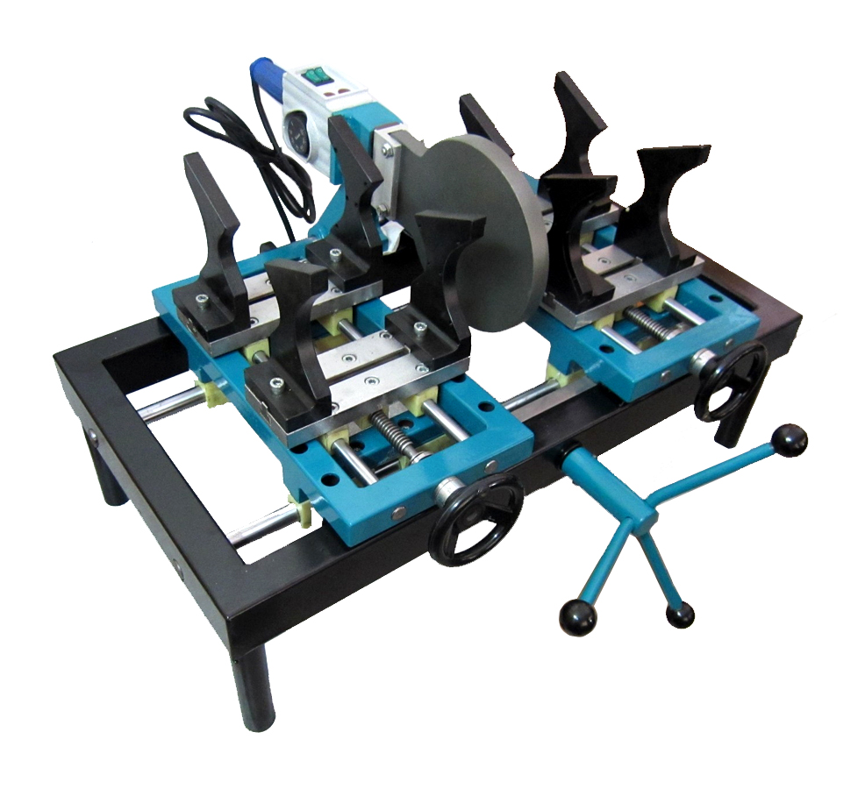 **SOCKET FUSION BENCH MACHINE**

**Technical Specifications:**

PIPEFUSER TK-550 comes with dual wattage (1200W and 2400W) 220 VAC double heating elements for faster heating time. 4000W transformer provided for 110 VAC operation

The thermostat control is infinitely adjustable for temperatures of up to 570 F

The heating plate diameter can accommodate pipe sizes of up to 6” DIPS

The heater plate is Teflon coated for butt fusion applications.

The positioning in the axial and transversal directions are made by means of a rack-and-pinion mechanism

Weight: 100 lbs

Dimensions: 34”Lx24”Wx14”H

Two-year limited warranty

GeoThermal Tools, Inc.  
www.pipefuser.com

973-810-5423