HAND-HELD SOCKET FUSION TOOL

TK-301

—Cheyenne's leading office supply store for over 50 years—

is proud to announce the acquisition of

A. Datum Corporation,

featuring the following:

- Imaging Systems
- Photocopiers
- Laser Printers
- Electric and Electronic Typewriters
- Desktop Computers
- Electronic Billing and Accounting
- Plus a thoroughly modern service department with factory-trained technicians

FABRIKAM, INC.

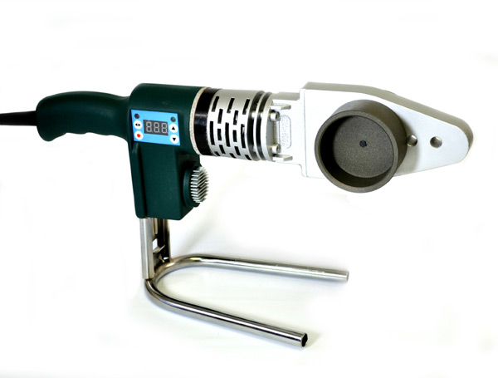

Technical Specifications:

- PIPEFUSER TK-301 comes with an 800 Watt, 120 VAC heating element with thermal switch feature to prevent damage to tool. Has 13' power cable
- PIPEFUSER TK-301 has an ergonomic plastic handle and a slide-in stand for stability
- The thermostat control dial is infinitely adjustable for temperatures of up to 600 F, with digital display of actual temperature
PIPEFUSER TK-301 comes in handy in tight spaces due to its narrow profile
- The tool can be used with heater adapter sizes of up to and including 2” IPS
Heater adapters are manufactured in accordance with ASTM F 1056 and are coated with stick-resistant material
- Three pairs of heater adapters can be connected at a time if needed
- PIPEFUSER TK-301 carries a two-year limited warranty

GeoThermal Tools, Inc.
www.pipefuser.com
973-8105423

